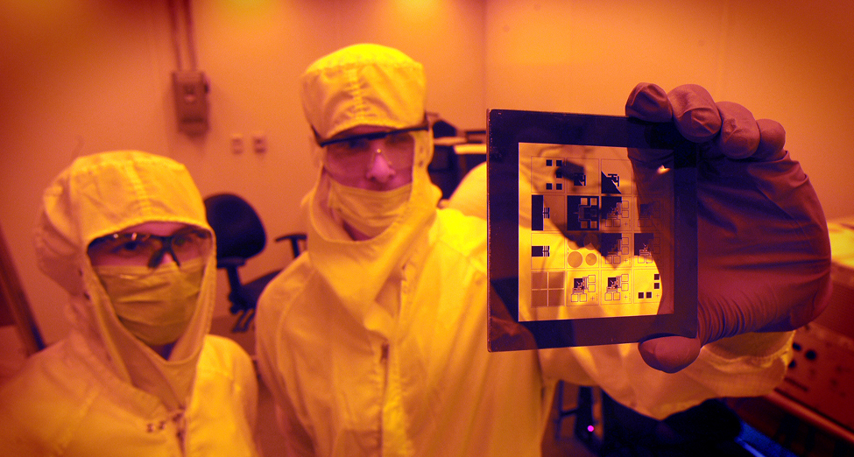

**Image from Applied Physical Sciences, University of North Carolina at Chapel Hill**

**http://apsc.unc.edu/**

**Photolithography: Patterning with light**

**SciREN Triangle 2016**

**Jun Yan, PhD.**

**Research Scientist**

**Chapel Hill Analytical and Nanofabrication Laboratory**

**The Department of Applied Physical Sciences**

**University of North Carolina at Chapel Hill**

**Email:** [**junyan@unc.edu**](mailto:junyan@unc.edu)

[**http://chanl.unc.edu/**](http://chanl.unc.edu/)

**Table of Contents**

**Discipline/topic areas** ...........................................................................................................................**3**

**Introduction** ......................................................................................................................................... **3**

**Grade Levels** ........................................................................................................................................**3**

**List of Standards** .................................................................................................................................**3**

**Duration** ............................................................................................................................................... **3**

**Group Size** ............................................................................................................................................ **3**

**Resources ......................................................................................................................................3**

**Setting …**................................................................................................................................................**4**

**Learning Objectives ......................................................................................................................** **4**

**Lesson Activity** ..................................................................................................................................... **4**

Preparation of the lesseon..................................................................................................................... 4

Engage.................................................................................................................................................... 4

Explore.................................................................................................................................................... 4

Explain….................................................................................................................................................. 5

Elaborate................................................................................................................................................. 5

Evaluate .................................................................................................................................................. 5

**Appendices………………………............................................................................................................ 6**

**Acknowledgement: I would like to thank Dr. Carrie Donley at the Chapel Hill Analytical and Nanofabrication laboratory who read the draft and provided many valuable suggestions for this completed version.**

**Discipline/topic areas:** Chemistry, Physical Science, and Physics

**Introduction:** Photolithography is a key technology that brought cellphones and computers into our daily lives. Photolithography is also being used to shrink complex and expensive medical diagnostic facilities into handheld devices, which we may soon use at home or on the go. This class will use Sunprint® paper to demonstrate photolithography. In this class, students will learn about the adsorption and emission of light in terms of the Bohr model, and learn about photolithography utilizing Ultraviolet (UV) light induced chemical reactions. Students will perform hands-on experiments and then present and reason through their results.

**Grade Levels:** High School (9-12)

**List of Standards:**

*NC Essential Standards:*

Chm.1.1.3 Explain the emission of electromagnetic radiation in spectral form in terms of the Bohr model.

PSc.2.2.4 Exemplify the law of conservation of mass by balancing chemical equations.

Optional content:

*Next Generation Science:*

HS-PS4-4. Evaluate the validity and reliability of claims in published materials of the effects that different frequencies of electromagnetic radiation have when absorbed by matter.

**Duration:** 50min

**Group Size:** This lesson plan is appropriate for all class sizes. Students can work in groupsof 5 or smaller.

**Resources:**

1. Sunprint® paper: fifteen 8”X12” sheets for $11.99 + shipping. One pack provides enough for 100 students.

<http://store.lawrencehallofscience.org/Category/sunprint-kits>

<https://www.amazon.com/SunPrint-W330-Paper-Kit/dp/B001KOGY3M/ref=sr_1_1?ie=UTF8&qid=1472478168&sr=8-1&keywords=sunprint+paper+kit>

1. Every group needs a printed transparency or small leafs from plants or small puzzle pieces (or any other small flat objects that block sun light)

Transparency films are available everywhere:

<https://www.walmart.com/ip/School-Mood-Smart-Copier-Transparency-Film-8.5-x-11-100-Pack/24078284>

1. Every group needs a container to hold water (bakeware, dinning ware, or Tuperware will work).
2. Every group needs a timepiece that can measure seconds and minutes (E.g. a watch or a timer)
3. UV lamp (**optional**) costs up to $25.99 + free shipping

<https://www.amazon.com/American-Black-Light-Fixture-Black-24BLB/dp/B0002F5544>

<https://www.bhphotovideo.com/bnh/controller/home?O=&sku=683740&gclid=CN_d9-Lj5s4CFUYbgQodnBEA0g&is=REG&ap=y&m=Y&c3api=1876%2C92051677562%2C&A=details&Q>=

1. Flat glass plate (**optional**)
2. Sunscreen **(optional)**

**Setting:** Indoor with a UV lamp. Or short outdoor times for exposing the Sunprint® paper to the sun light. (Cloudy days can use as much as 5X time compared to sunny days. Will not work on rainy days.)

**Learning Objectives:**

* Recall and repeat experiment procedure
* Explain how an atom absorbs and emits electromagnetic radiation using the Bohr model
* Compare different results, and provide reasons for the different observations
* Balance the chemical reaction equation, estimate the result of extra-long exposure time.
* Optional: learn about the spectrum of sunlight, hypothesize the results if we block UV light from sun light and use experiment to test the hypothesis.

**Lesson Activity (detailed description with pictures in Supplemental information):**

1. Lesson activity preparation:

1. Teacher needs to watch the Sunprint® process videos and read the slides provided.

Video #1: <https://www.youtube.com/watch?v=vqbDerkJCxk>

Video #2: <https://www.youtube.com/watch?v=nxKipUY7O2M>

Slides: see **Supplemental information** 1

1. Cut 8”X12” Sunprint® paper into 3”X4” sheets, and put them back to the black bag!
2. Prepare UV blocking pieces. You can start involving students at this step. Ask them for ideas of what to use to block the UV light (transparencies, items from outside, etc.). Maybe have them watch videos #1 and #2 so that they know what types of things will work. Teacher needs to remind them that their design needs to fit within a 3”X4” area.

*Engage*

2. At the beginning of the class show the YouTube video about nanofabrication and ask every student to write down everything they learn about photolithography, cleanrooms, and transistor fabrication from the video.

<https://www.youtube.com/watch?v=qm67wbB5GmI>

(It’s recommend to show the full video or at least the 1st half)

3. Ask every student group to discuss and list what they know about photolithography and the questions they have about photolithography. Then ask every group to provide their list to the class, and try to compile a complete list of knowns and unknowns on the board.

4. Explain and demonstrate photolithography in detail using the Sunprint® procedure in the **Supplemental information 1** slides. In this step, teacher can do the Sunprint® demo with 2 min exposure time.

*Explore*

5. Every group will do their own Sunprint® experiments five times for 10 sec, 20 sec, 30sec, 40sec, and 50sec exposure time.

*Explain*

6. Ask students why the UV light can change the solubility of the coating on the Sunprint® paper.

7. Teacher can now explain the chemistry of the Sunprint® chemistry in the **Supplemental information** 1.

1. Explain why UV light can induce a chemical reaction. (**NC Essential Science Chm.1.1.3 Explain the emission of electromagnetic radiation in spectral form in terms of the Bohr model.**)
2. (optional) ask students to calculate the energy that an electron can gain from a 380nm UV radiation using equation E=h⋅ν=h⋅c/λ

h (Planck constant), 6.626×10−34 J⋅s

c (Speed of light in vacuum) 2.998×108 m/s

λ (light wave length) 380 nm (nm =10−9 m)

1. Provide equation:

x[FeII(CN)6]4-  + yFe3+  Fe4[Fe(CN)6]3

Ask students to find x and y to balance the chemical reaction **(NC Essential Science PSc.2.2.4 Exemplify the law of conservation of mass by balancing chemical equations.)**

*Elaborate*

8. Now check if the students understand that radiation is required for the Sunprint® process. The teacher can ask students why the Sunprint® paper shows different shades of blue? In this step, we try to make students understand that longer exposure to UV radiation generates more Fe4[Fe(CN)6]3; and more Fe4[Fe(CN)6]3 makes a darker blue color.

9. The teacher can now explain a bit about nanofabrication and photolithography using background information in the **Supplemental information** 2.

10. Ask every group (or every student) to choose their 2 favorite images and give reasons for why they like these the best. There is no standard answer for this activity – some may like the color contrast or being able to print fine lines. While others may like a print just because it looks Carolina blue or Blue Devil blue. So let their voices be heard and show them that the best result depends on their goals, criteria, or even emotions.

*Evaluate*

11. (optional) Teach students about the spectrum from sunlight which produces radiation at different energies and different frequencies. Ask the students if we can block the UV radiation, can the remaining radiation still expose Sunprint® paper properly? (**Next Generation science: HS-PS4-4. Evaluate the validity and reliability of claims in published materials of the effects that different frequencies of electromagnetic radiation have when absorbed by matter**)

12. (optional) Ask students design experiment to test their hypothesis (can UV blocked sun light expose Sunprint® paper?)

13. (optional) If students can create an experimental plan using sunscreen that would be great. If not, without telling students what it is, handout the UV blocking film (sunscreen coated transparency) and ask the students to repeat the Sunprint® process for 1min while covering half of their Sunprint® paper. Ask the students why the covered areas aren’t fully developed? What could be on the covering film? They should be able to point out it is sunscreen.

14. Revisit the two different types of photolithography (positive vs negative) in the **Supplemental information** 2. Ask students which type the Sunprint® process is.

15. Ask student if we keep increasing exposure time, could we get darker and darker blue?

The answer is no. Because there is only limited amount [Fe(CN)6]3- . Once they are all convert into [Fe(CN)6]4- , radiation can’t generate more [Fe(CN)6]4-

**Appendices:**

1. **Supplemental information** 1 -The Sunprint process.pptx
2. **Supplemental information** 2- Introduction to nanofabrication and photolithography.pptx
3. Additional Reading - A negative photoresist.pdf
4. Additional Reading - Cyanotype chemistry.pdf