Small group activity 1: Scale in microscope images.

When looking at images from a microscope, how do you tell how big something is?

When scientists take pictures with a microscope, they put something called a scale bar on the picture. This is a line showing the scale of the picture. The length of the line is shown in the picture.
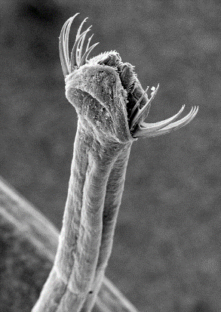
For example, the head of this worm looks like something out of Star Wars, like it could eat you whole.

Can you use the scale bar to figure out how big across the head of this worm is?

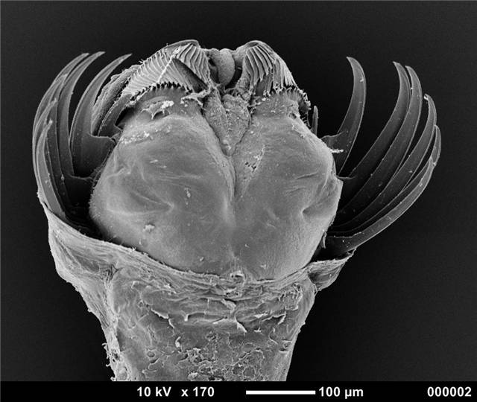
What kind of microscope is good for looking at pollen?
Here are some images of pollen grains taken with a light microscope and with a scanning electron miscroscope (SEM).
Light Microscope SEM -whole grain SEM -zoom in 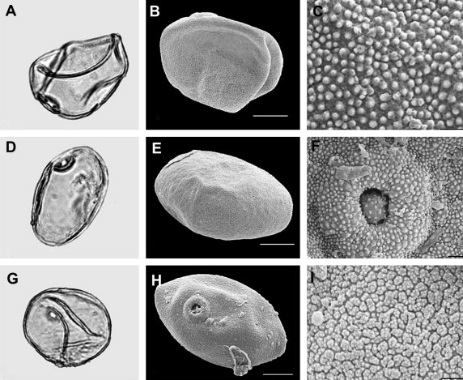
http://dx.doi.org/10.1016/j.quascirev.2008.12.025

Small group activity 2:

Pollen diversity:
Pollen comes in many shapes and sizes.
Largest pollen is from squash: 200um
-twice the thickness of a human hair (100um)
Smallest pollen is from forget-me-not flowers: 5um
-about the size of a bacteria (1-10um)

This picture shows the range of pollen shapes and sizes.
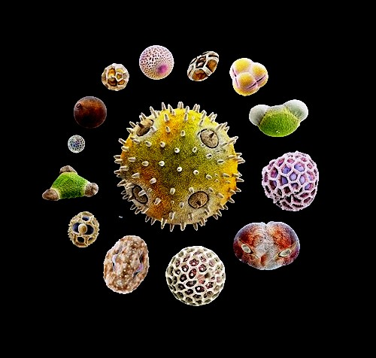
Squash flower pollen particle (center) is the largest, while the grain at the bottom right (red arrow) – is the tiny forget-me-not pollen. (Photo: Martin Oeggerli)

Why do you think pollen might come in so many different shapes and sizes?

For many people pollen causes allergies.
What are some symptoms of a pollen allergy?

What factors influence how likely a particular pollen is to cause an allergy?

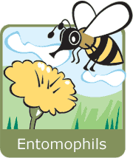 | - Entomophils (from the Greek Entomos= insect) ➔ these plants reproduce themselves by means of insects. These usually have very eye-catching and beautiful flowers in order to attract insects, and so their pollen is normally quite sticky. When an insect alights on a flower to suck the nectar, pollen sticks to the hair on its legs. Then, when the insect goes to another flower, some of this pollen sticks and thus fertilizes the plant.
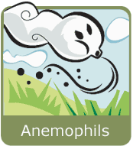 | - Anemophils (from the Greek Anemos = wind) ➔ these plants reproduce themselves by means of the wind. They do not have beautiful flowers, because they do not need to attract insects. So, they usually have small pollen, that comes off very easily and in great quantities when the wind blows, and is carried by the wind great distances ("aero-roaming"), thus permitting the fertilization of other plants of the same species.

For each of the pollen grain images, fill out the table:
Plant | Scale bar size (uM) | Pollen Size (cm) | Pollen Size (uM) | Shape | Method of dispersal | Sneeze?

Outdoor Activity
Collect your own pollen samples. Look for blooming flowers and try to scrape some pollen off of the stamen. Look for the less obvious flowers of the wind pollenated plants (like grasses and trees). Take notes about where your pollen came from.

If you have light microscopes in your class room, take a look at your pollen with the light microscope. Draw what you can see.

Your teacher will send us the pollen you have collected and we will send you back SEM images of the pollen showing the size and shape. Look up information about your pollen, the plant it came from, and write the story of your pollen.

