Background:

Optional background activity on size and scale to get students thinking about small size scales and small units (micrometers and nanometers).
http://www.nnin.org/education-training/k-12-teachers/nanotechnology-curriculum-materials/size-and-scale-learning-about

Watch 4 min video to become acquainted with basic parts of a flower and pollen biology:
https://www.youtube.com/watch?v=djPVgip_bdU

Small group activity 1: Scale in microscope images.

When looking at images from a microscope, how do you tell how big something is?

When scientists take pictures with a microscope, they put something called a scale bar on the picture. This is a line showing the scale of the picture. The length of the line is shown in the picture.
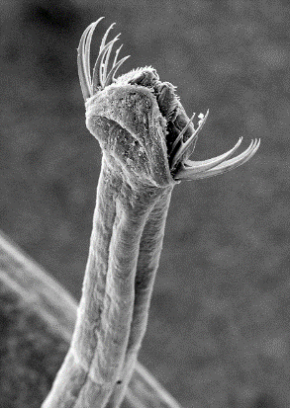
For example, the head of this worm looks like something out of Star Wars, like it could eat you whole.

Can you use the scale bar to figure out how big across the head of this worm is?
Measure how big across the worm head is with a ruler in inches.
Measure how big the scale bar is in inches.

Use the following formula to calculate how big the worm head is:

Size of scale bar (in um) * size of worm head (in inches)/size of scale bar (in inches) = size of worm head (in um)
Bonus info: These worms are chaetognaths. They are tiny worms that live in the ocean.
https://en.wikipedia.org/wiki/Chaetognatha

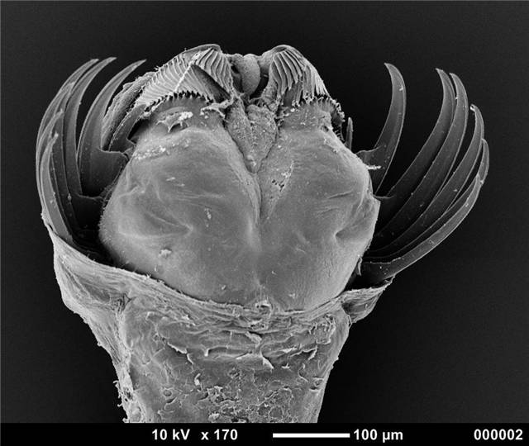

What kind of microscope is good for looking at pollen?
Here are some images of pollen grains taken with a light microscope and with a scanning electron miscroscope (SEM).
Light Microscope SEM -whole grain SEM -zoom in 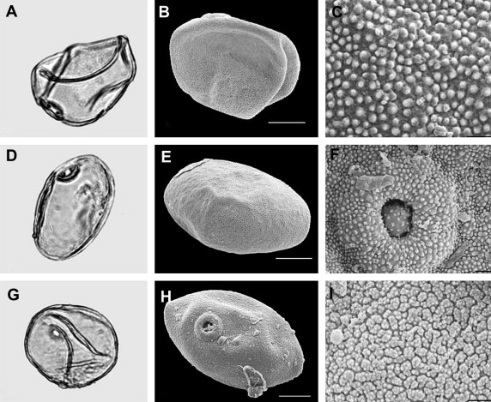
http://dx.doi.org/10.1016/j.quascirev.2008.12.025
Which microscope would you choose? Why? Why do you think they are different?
The SEM works like a light microscope, but uses electrons instead of light to form an image. Electrons are smaller, so you can zoom in further than the light microscope. The SEM also shows the surface of the pollen grains better because it uses electrons that bounce off the surface to create the image, while the light microscope uses light that passes through the grain to create the image.
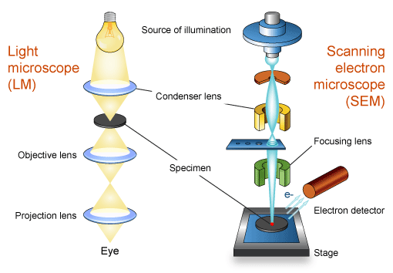
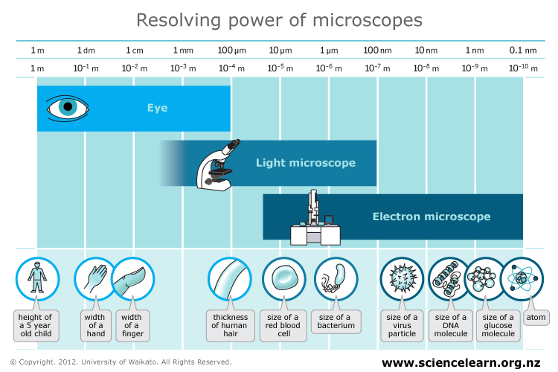

Optional:
Try virtual SEM
http://myscopeoutreach.org/virtualSEM_explore.html

See how the same samples look as you zoom in with a light and then scanning electron microscope.
http://myscopeoutreach.org/letsZoomIn.html

Small group activity 2:

Pollen diversity:
Pollen comes in many shapes and sizes.
Largest pollen is from squash: 200um
-twice the thickness of a human hair (100um)
Smallest pollen is from forget-me-not flowers: 5um
-about the size of a bacteria (1-10um)

This picture shows the range of pollen shapes and sizes.
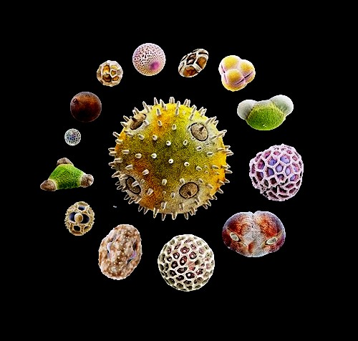
Squash flower pollen particle (center) is the largest, while the grain at the bottom right (red arrow) – is the tiny forget-me-not pollen. (Photo: Martin Oeggerli)

Why do you think pollen might come in so many different shapes and sizes?

Have students speculate and write down some ideas
-mode of transport-wind vs insects, birds, bats
wind dispersed pollens tend to be smaller and smoother
creature dispersed pollens tends to be larger and bumpier

For many people pollen causes allergies.
What are some symptoms of a pollen allergy?
Pollen allergy symptoms most often include:
- nasal congestion
- sinus pressure, which may cause facial pain
- runny nose
- itchy, watery eyes
- scratchy throat
- cough
- swollen, bluish-colored skin beneath the eyes
- decreased sense of taste or smell
- increased asthmatic reactions

What factors influence how likely a particular pollen is to cause an allergy?
-wind pollenated plants-increase exposure, plus need to be smaller for greater dispersal
-size of pollen grains –some are too big to cause allergic reaction

“The average grain of pine pollen is about 60-90 micrometers in diameter. This is too big to get very far up your nose. Oak pollen is much less visible. Even though there is about as much oak pollen in the air in my neighborhood as pine pollen, you don’t see the oak pollen unless you shake it on to a dark surface. Oak pollen is tiny, 24-38 micromters, or less than half the size of pine pollen. You may not notice oak pollen, but your nose does.”
http://www.planetexperts.com/allergic-to-pollen-its-getting-worse/

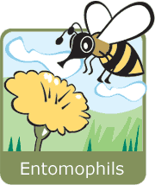 | - Entomophils (from the Greek Entomos= insect) ➔ these plants reproduce themselves by means of insects. These usually have very eye-catching and beautiful flowers in order to attract insects, and so their pollen is normally quite sticky. When an insect alights on a flower to suck the nectar, pollen sticks to the hair on its legs. Then, when the insect goes to another flower, some of this pollen sticks and thus fertilizes the plant.
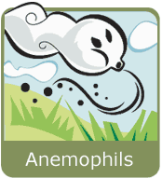 | - Anemophils (from the Greek Anemos = wind) ➔ these plants reproduce themselves by means of the wind. They do not have beautiful flowers, because they do not need to attract insects. So, they usually have small pollen, that comes off very easily and in great quantities when the wind blows, and is carried by the wind great distances ("aero-roaming"), thus permitting the fertilization of other plants of the same species.

For each of the pollen grain images, fill out the table:
Plant | Scale bar size (uM) | Pollen Size (cm) | Pollen Size (uM) | Shape | Method of dispersal | Sneeze?

Outdoor Activity
Collect your own pollen samples. Look for blooming flowers and try to scrape some pollen off of the stamen. Look for the less obvious flowers of the wind pollenated plants (like grasses and trees). Take notes about where your pollen came from.

If you have light microscopes in your class room, take a look at your pollen with the light microscope. Draw what you can see.

Your teacher will send us the pollen you have collected and we will send you back SEM images of the pollen showing the size and shape. Look up information about your pollen, the plant it came from, and write the story of your pollen.

